Webex guidance

Introduction

This is basic guidance for staff who want to try Webex. It is not comprehensive training. See also the Getting Started - Webex Meetings pages as well as the Getting Started - Webex Training pages.

In your Brightspace module, click Communication and Collaboration (Fig 1). The menu has Webex and Virtual Classroom (Bongo).

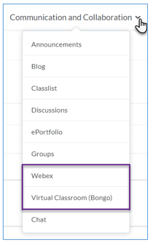
Figure 1: Communication and collaboration menu
Note:
- Virtual Classroom (Bongo) currently opens Bongo Premium. In Semester 1 this will revert to Bongo basic (no breakout rooms).
- Webex gives you access to Webex Meetings and Webex Training. Webex Training is the Blackboard Collaborate replacement (with breakout rooms).

Setting up Webex
Click Webex. Cisco Webex Education Connector for Teachers loads, it takes approximately 20 seconds.

Support: At the top right of the window is a Support button.

Figure 2: Support button
Clicking the support button takes you to The Cisco Webex Education Connector for Teachers help pages.

You are welcome to explore this but note we may not have all of the features described.
When you first open Webex in your module you have to set it up by choosing the features you want. This is easy and usually only takes 4 or 5 clicks.

Cisco (the company that provides Webex) calls the VLE integration the “Cisco Webex Education Connector for Teachers”. This setup lets you use Webex Meetings and Webex Training in the VLE.

Virtual meetings and Office Hours are off by default:
- Click the Virtual meetings checkbox to connect to Webex Meetings.
- Click the Office Hours checkbox to connect to your personal room.
- Click Apply (Fig. 3).

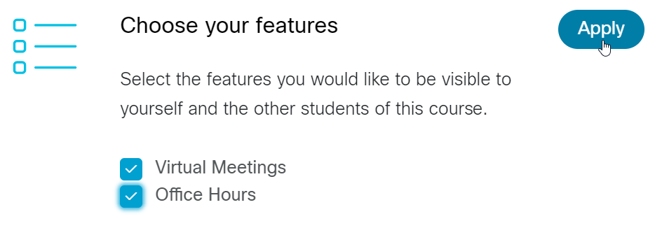
Figure 3: Choose your features
Opposite Time Zone - do not click Sync unless you will be holding a meeting with people in a different time zone (Fig. 4). Scroll down to Authorize with LMS. You must click Authorize with LMS before you can use Webex. This is a security feature that ensures the security of your meetings. Click Authorize.

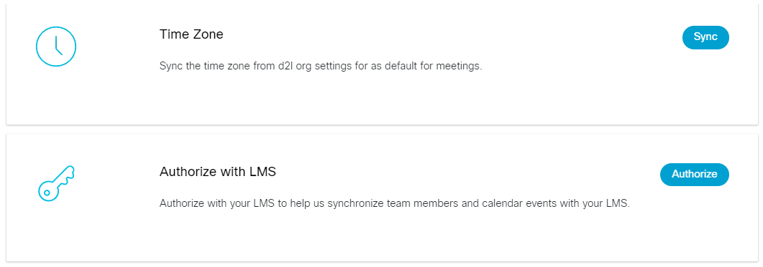
Figure 4: Time Zone and Authorize
A window opens (Fig 5), click the Accept button to allow Webex to operate using your account.

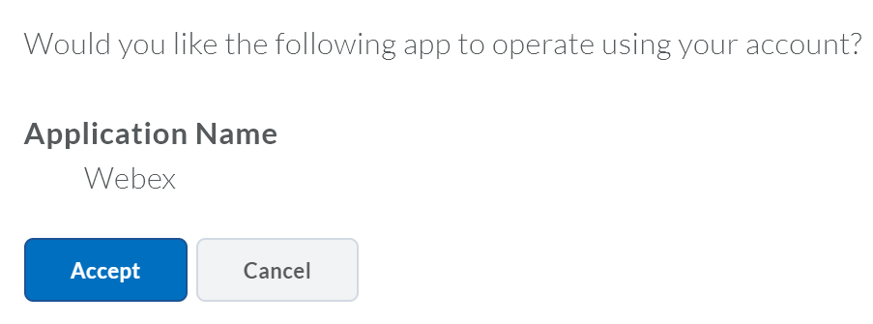
Figure 5: Allow Webex to operate using your account
Note: You may have to complete a CAPTCHA (picture grid question) to prove you are not a robot. You only have to do this once. Once you have done this the Authorize button will appear greyed out.

Webex meetings attendance grading is optional. If you want to award points to students when they attend a meeting, click Turn on (Fig 6.).

Figure 6: Webex meetings attendance grading
You have now completed the setup process.

You can now create Virtual Meetings using the Virtual Meetings Tab (Fig. 7) and set up Office Hours meetings in the Office Hours tab. You can check the number of scheduled meetings and booked office hours in the Analytics tab. If you want to change your setup, click the Setup tab.

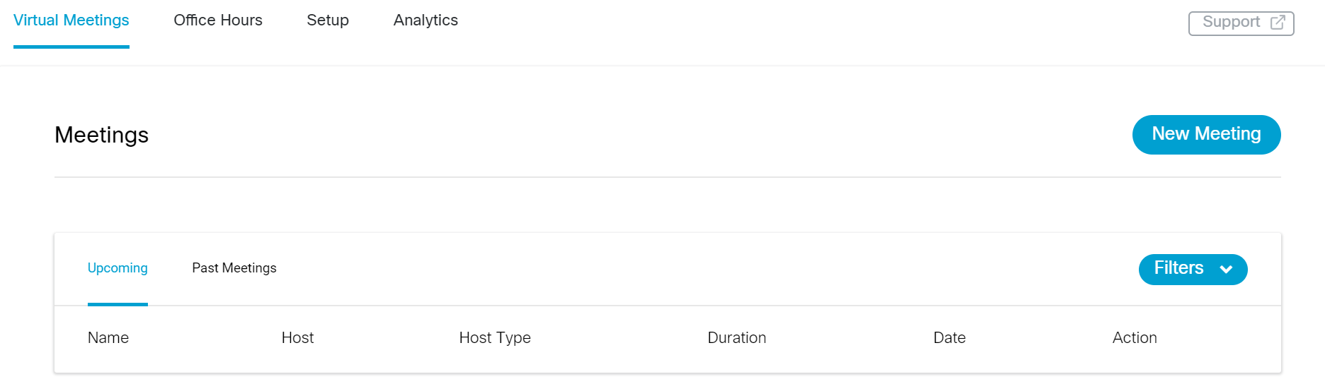
Figure 7: Virtual meetings tab
To create your first meeting, click the Virtual Meeting tab, click New Meeting (Fig. 7). Click Sign in with Webex Meetings and sign in with your UHI id.

Note: Your email must be your ID@uhi, not your name, e.g. eo03ab@uhi.ac.uk.

Click Next. Click Accept to accept all the permissions (Fig. 8).

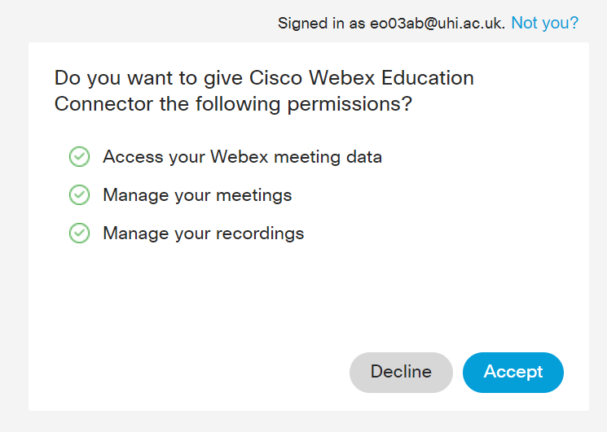
Figure 8: Accept permissions
The New Meeting page opens (Fig. 9).

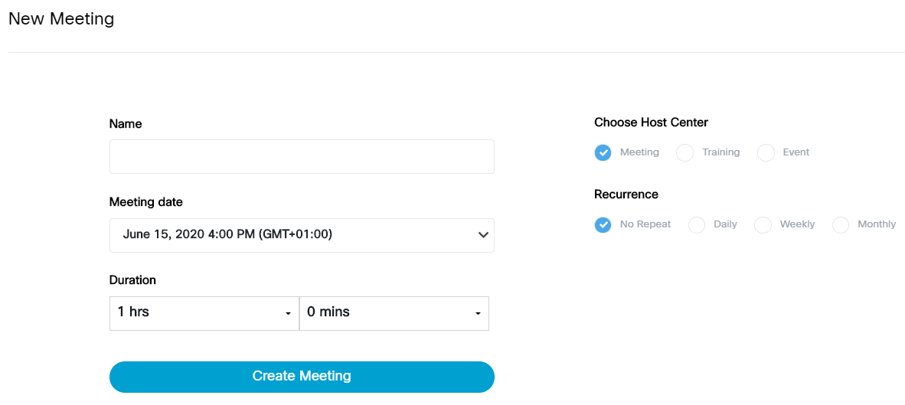
Figure 9: Setup New Meeting
Important: this is where you decide what meeting type you need. Under “Choose Host Center”, select Meeting (similar to Bongo basic) or Training if you want to use break out rooms. Once you have selected Meeting or Training you can set up your meeting.

When your meeting is created, click Host to enter the meeting, Edit to change the details, e.g. timing, or Delete to cancel the meeting.

Remember: At any time, click the Support button to read more about setting up Virtual Meetings and Office Hours in the Webex Education Connector (Fig 10). The Support site will open in a new tab in your browser, so you can continue to create meetings in Brightspace.

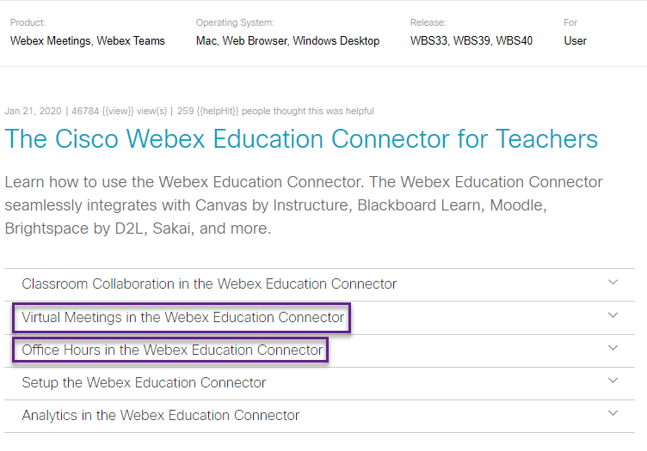
Figure 10: Cisco support

